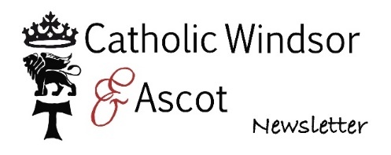
APPLICATION FOR FIRST RECONCILIATION AND
FIRST HOLY COMMUNION 2024/2025

PLEASE COMPLETE ALL SECTONS AND PRINT CLEARLY IN BLOCK CAPITALS
Names of parents

Name of Child: Surname of Child:

Baptised at: Church

On by
(A copy of your child’s Baptism Certificate must be supplied)

Home Address:

Phone Nos: Mob No:

Email:

Date of birth: School:
I OR We attend Mass weekly at St Francis, Ascot

I OR We would like (name of child)
to make HIS OR HER First Reconciliation and First Holy Communion in 2024/2025.

Signed: Name: Date:
Please complete this form online and email it as an attachment to
stfrancisascot@portsmouthdiocese.org.uk
GDPR Information
Information provided on this form, together with all other personal data held about these individuals by the Parish and the Diocese of Portsmouth, is processed in accordance with the Diocese's Privacy Notice available online or from St Francis, Ascot.

